Web Dev – Report

**Section A – Directory structure:**

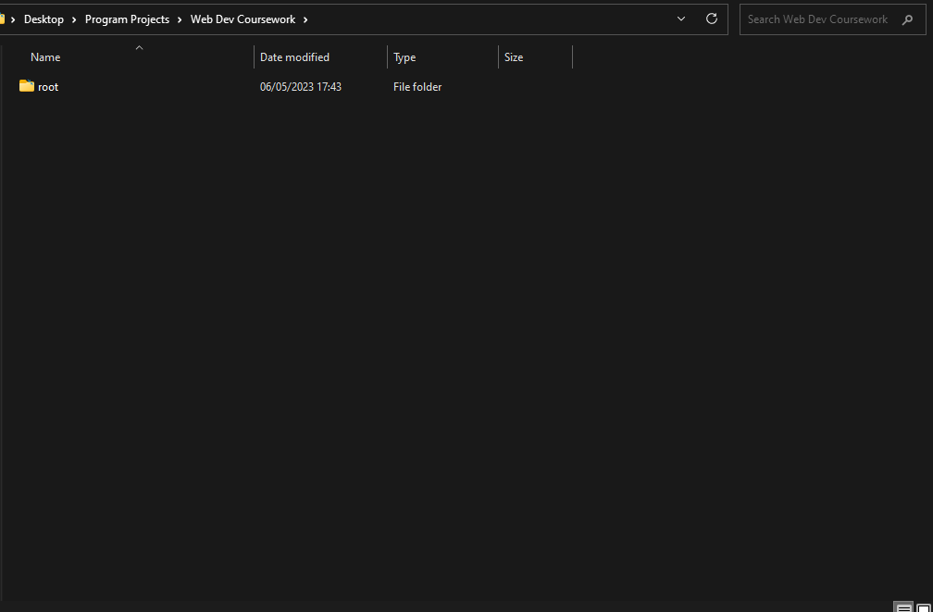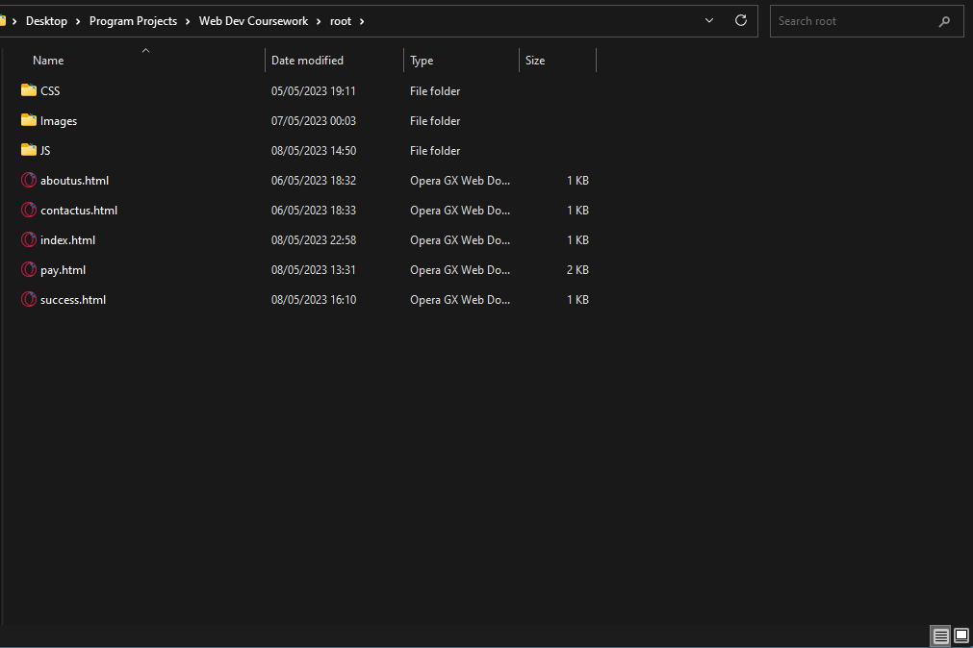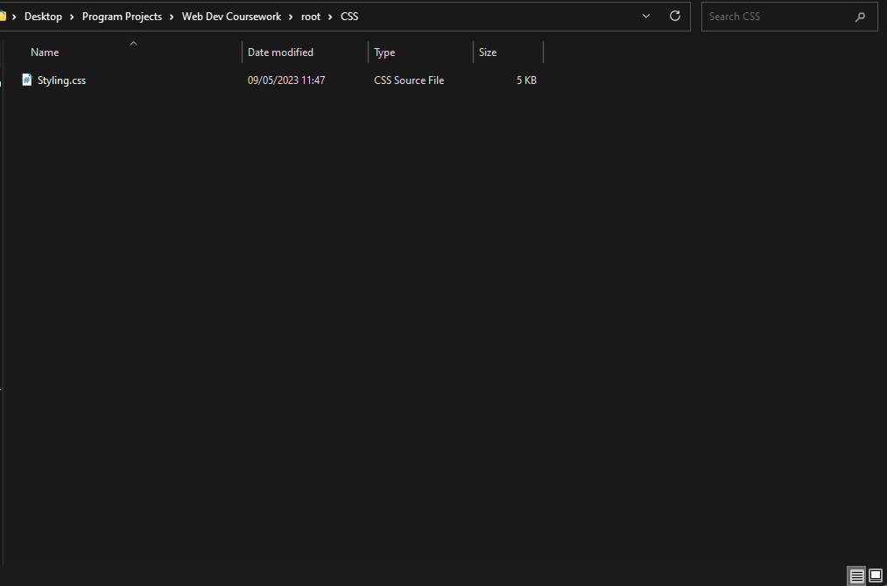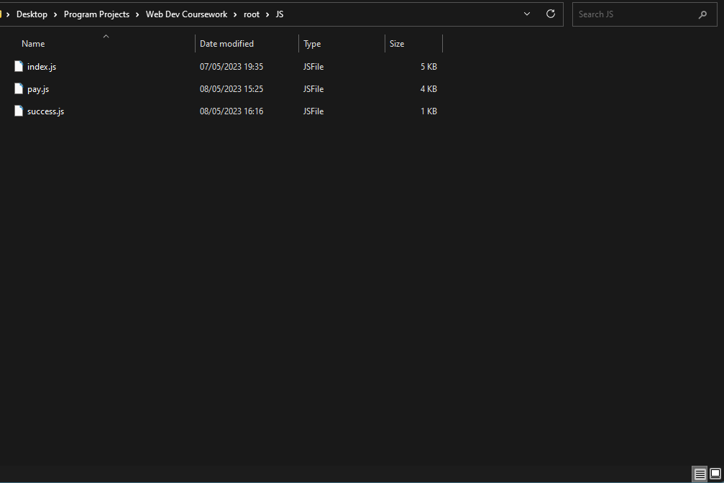

As shown in the screenshots above the files are located in a root directory folder where they are separated into their respective folders, from here the html is coded to access the single CSS file which each of the HTML files use in order to keep styling consistent and look similar. Additionally the JavaScript files are all kept within the JS folder and named so that each file can easily be matched to its HTML counterpart.

index.html:

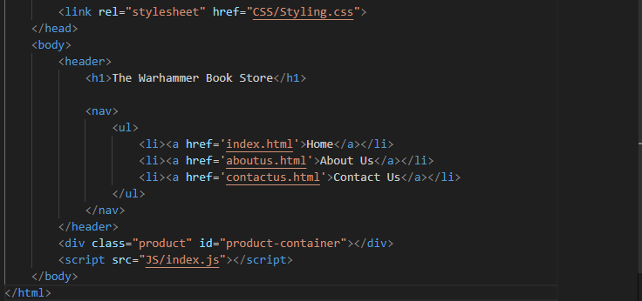

pay.html:

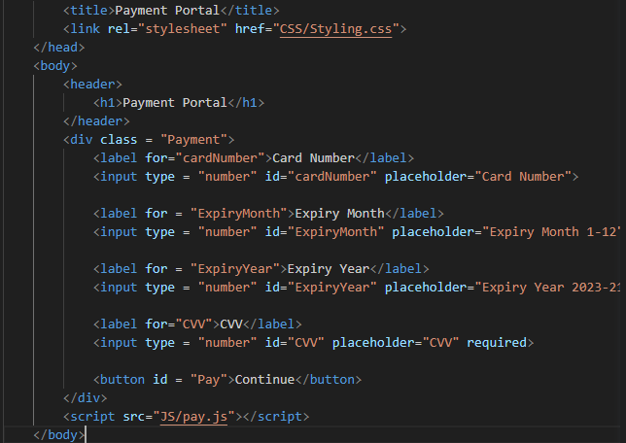

success.html:

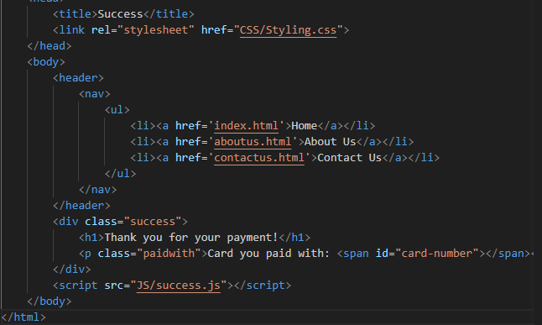

aboutus.html:

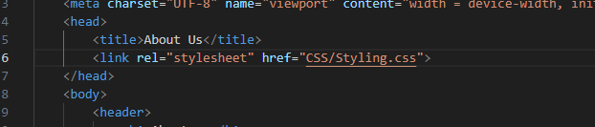contactus.html:



**Section B - Frontend:**

Desktop view of index.html:

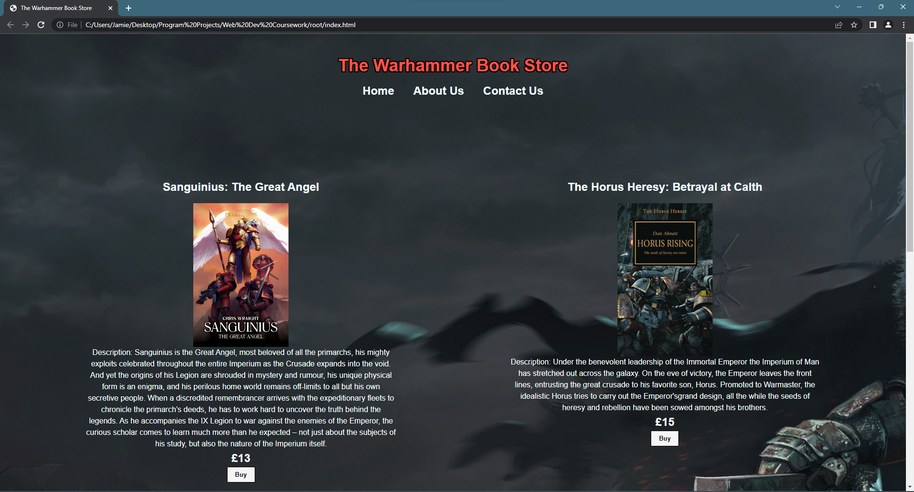

Mobile view:

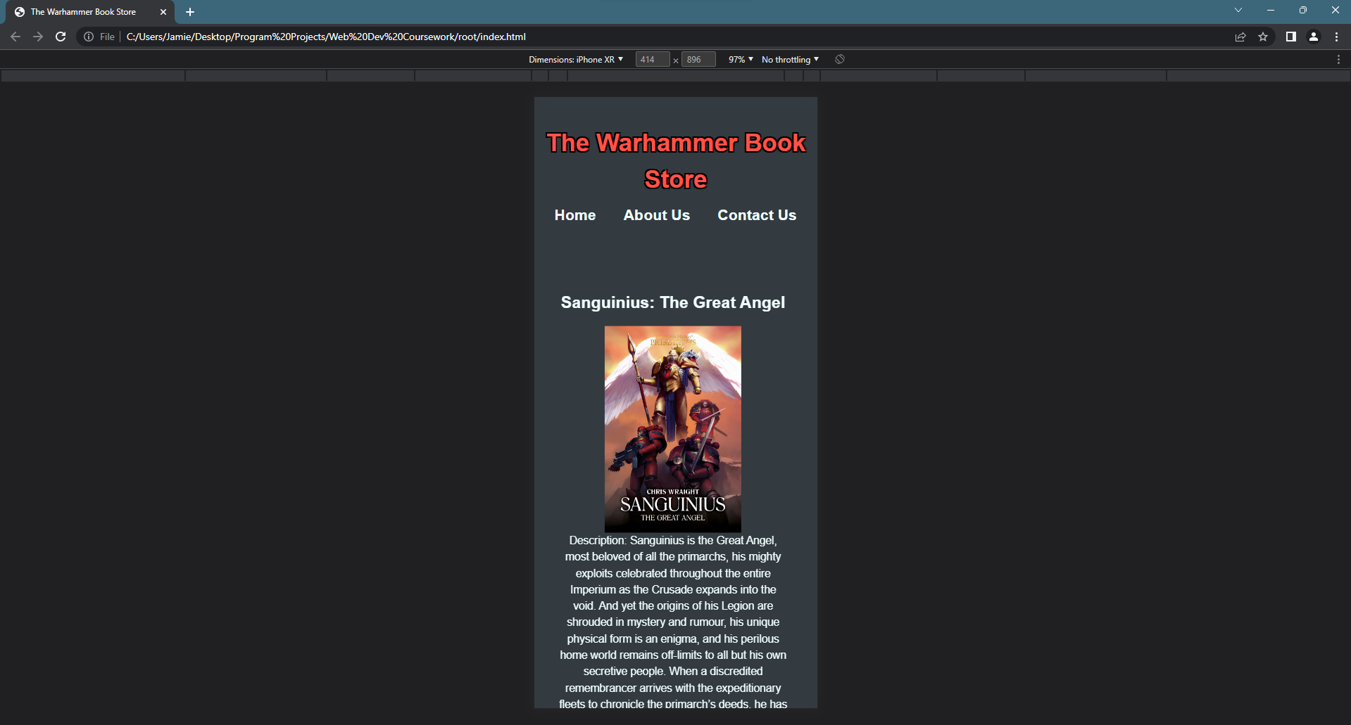

**Section C - RESTful:**

All my Javascript code to send a request to the server:

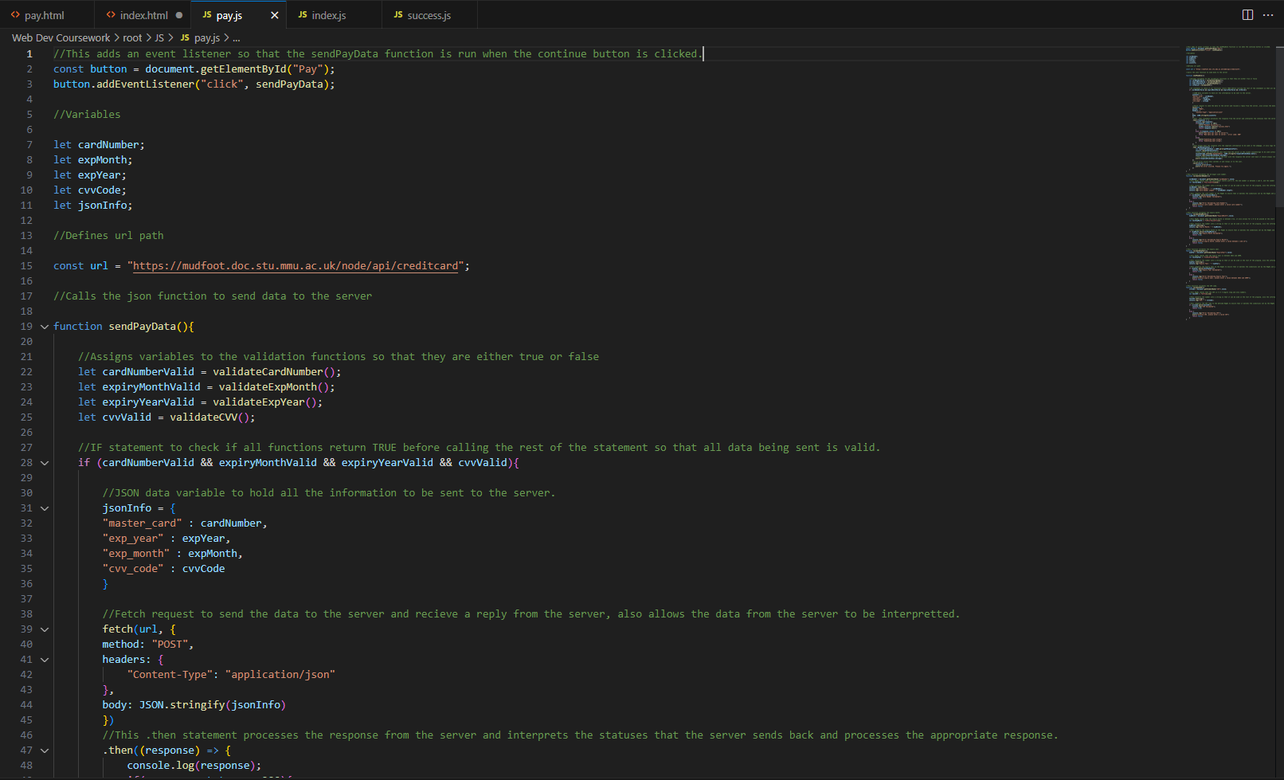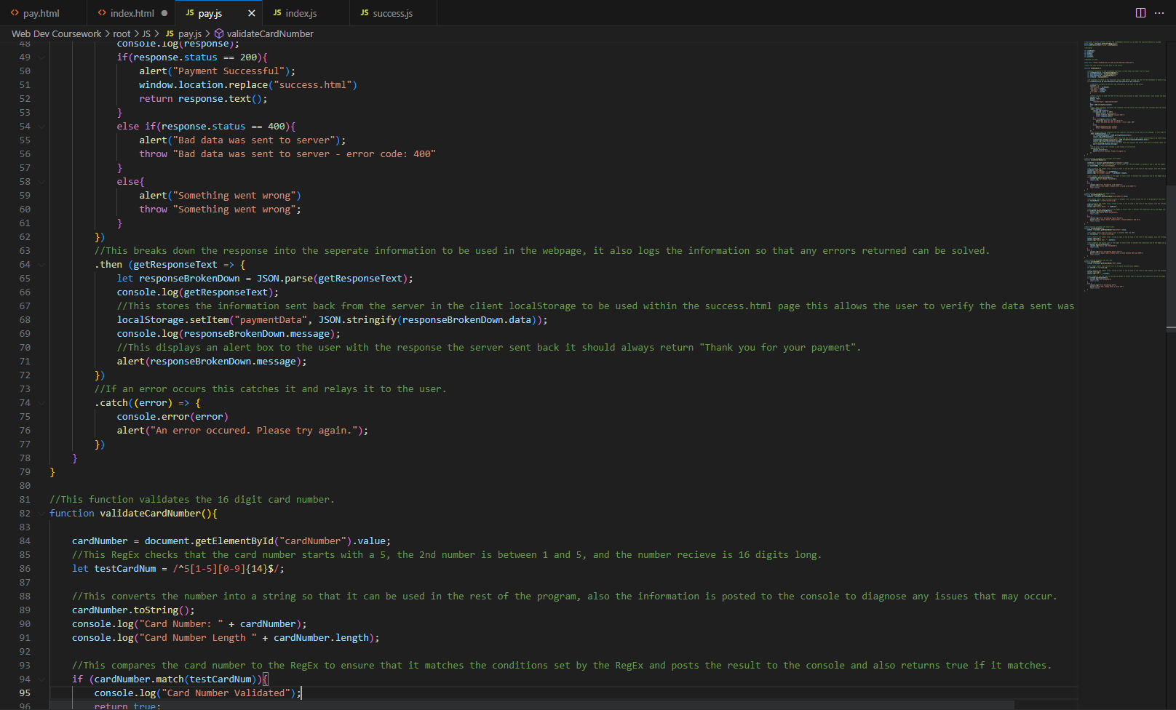 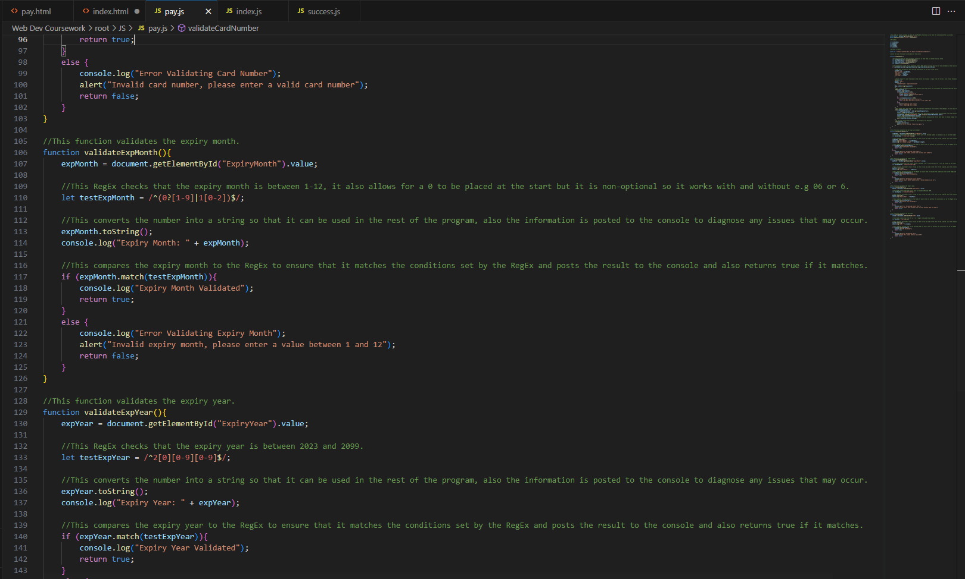 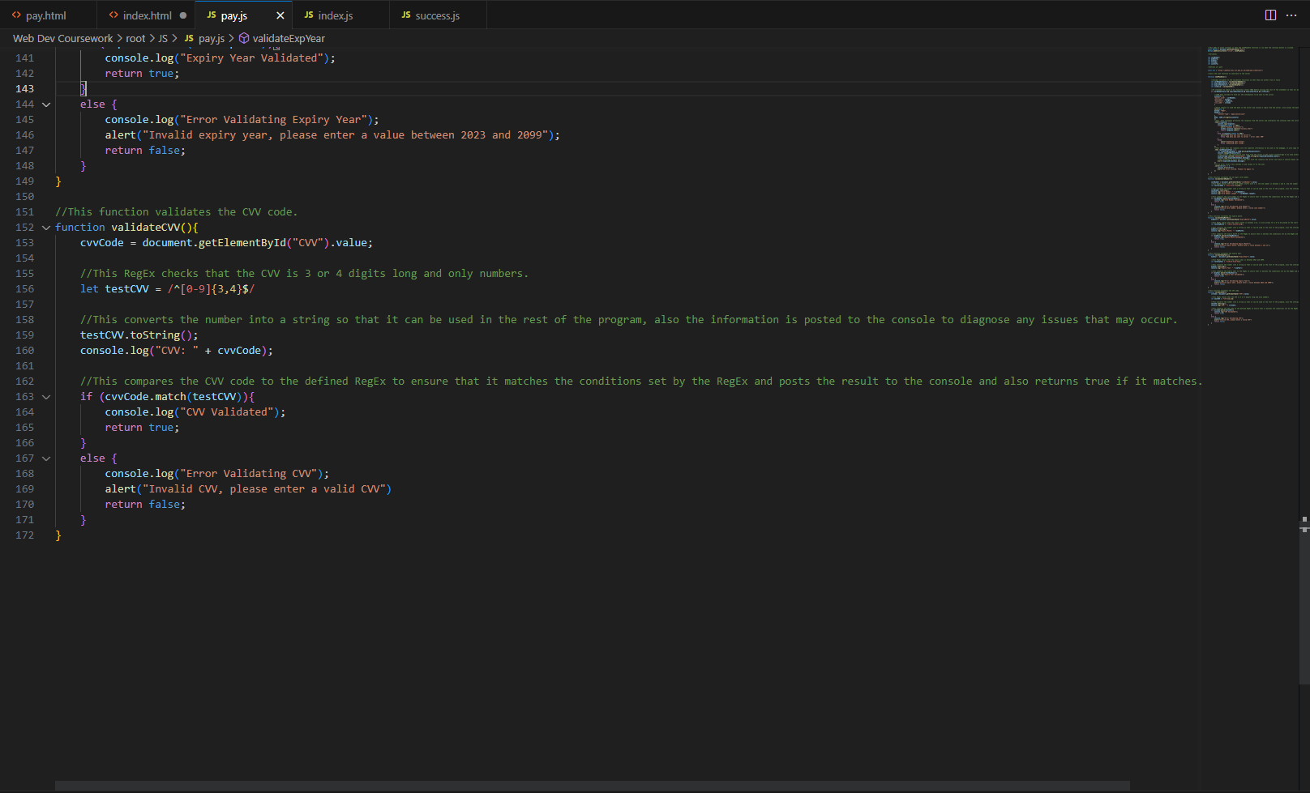

Raw JSON Data:

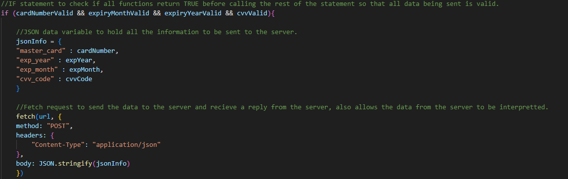

Verification Failure:

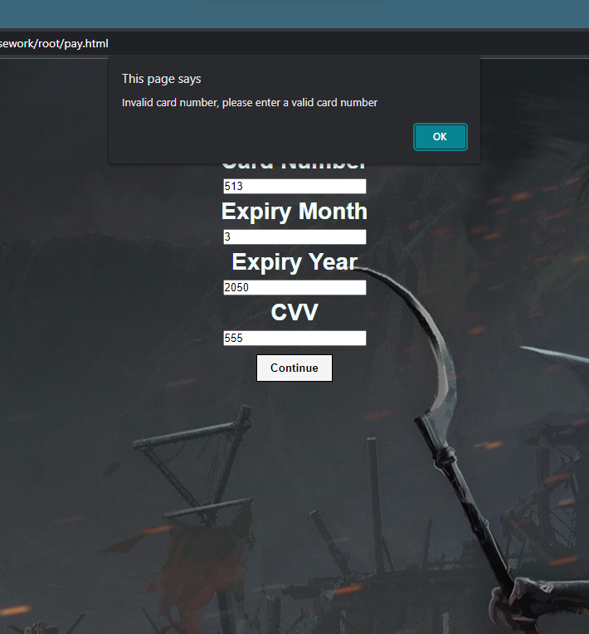 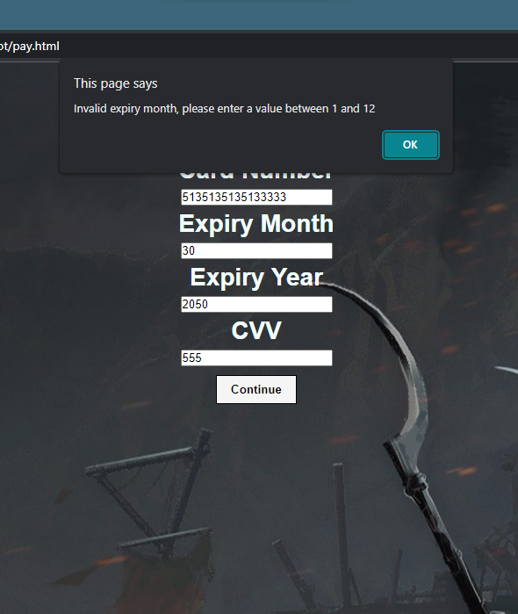 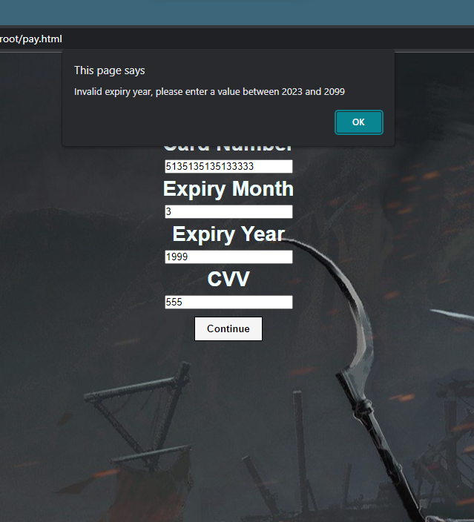 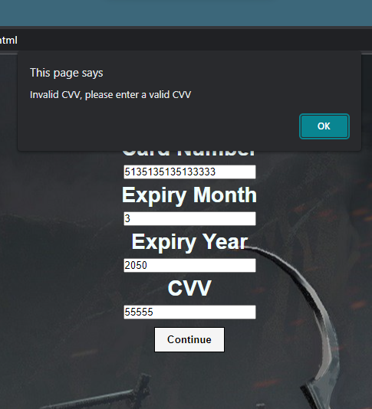

Payment Successful:

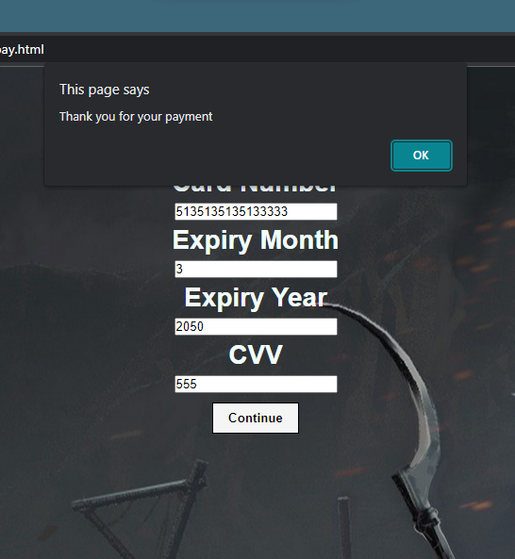 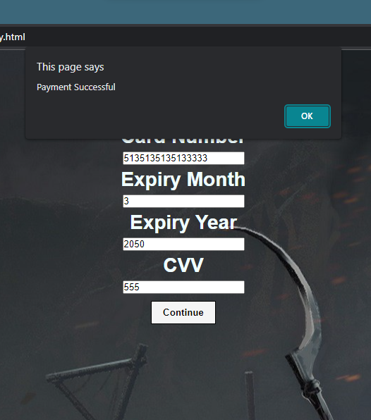

User is then redirected to the success.html page:

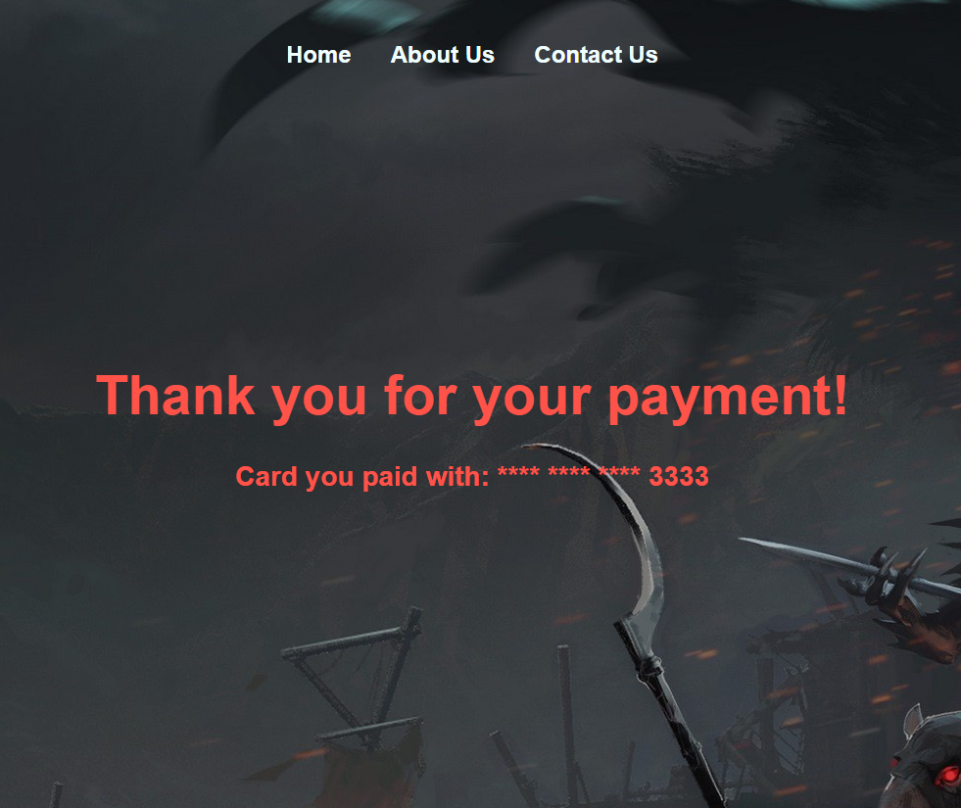

Success.html – Javascript code:

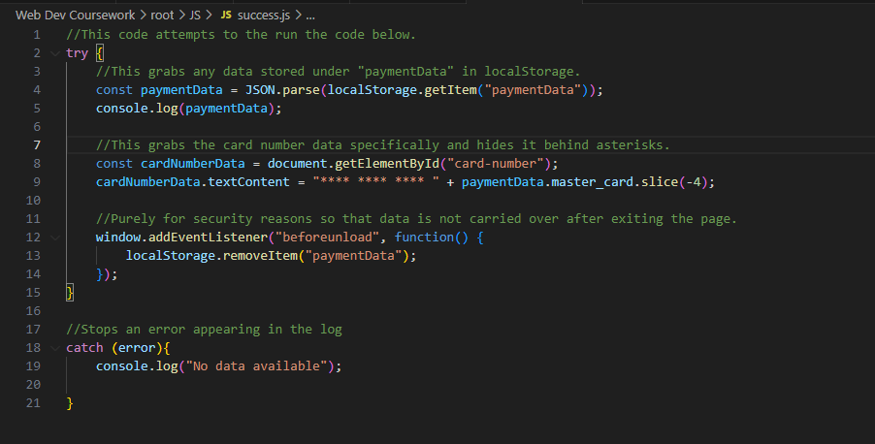

**Section D – Usability and accessibility:**

* On the pay.html page if the user inputs information wrong they are told exactly where the information provided is incorrect saving them time and making sure they don’t have to diagnose the issue themselves.
* On the success.html page the user is provided with the information of the card they used to make the payment, in order to protect the privacy of the users data only the last 4 digits of the card are shown.
* On the success.html page the card information is not sent back to the user for security reasons and is instead stored temporarily on their computer to show them the card they paid with, an event listener is added so that the information is deleted once the user leaves the page for security.
* When the user uses a smaller screen the website adapts to that and makes some of the text smaller so that it is still easy to read and keeps the website a readable and usable size.
* There is a high difference in constrast between the background and the text on the page to make it more readable to users, also the background is a darker colour so that the website is easier on the user’s eyes and does not blind them when the website is opened.